 | 
COUNCIL ASSESSMENT REPORT
SYDNEY SOUTH PLANNING PANEL

PANEL REFERENCE & DA NUMBER | PPSSSH-211 & DA-811/2025
PROPOSAL | Demolition, tree removal and the construction of a new community centre with multi-purpose hall, multi-purpose meeting room, covered outdoor area, kitchen, foyer / lobby area, amenities and plant areas
ADDRESS | 4A Olympic Parade, Bankstown
APPLICANT | Collins and Turner Pty Ltd
OWNER | City of Canterbury Bankstown
DA LODGEMENT DATE | 22 July 2025
APPLICATION TYPE | Development Application
REGIONALLY SIGNIFICANT CRITERIA | Schedule 6 – Regionally significant development of State Environmental Planning Policy (Planning Systems) 2021 as Council is the owner of the land on which the development is proposed and the development has an estimated development cost of more than $5 million.
EDC | $7,112,571.04 (excluding GST)
CLAUSE 4.6 REQUESTS | None
KEY SEPP/LEP | - State Environmental Planning Policy (Biodiversity and Conservation) 2021  - State Environmental Planning Policy (Planning Systems) 2021  - State Environmental Planning Policy (Resilience and Hazards) 2021  - State Environmental Planning Policy (Sustainable Buildings) 2022  - State Environmental Planning Policy (Transport and Infrastructure) 2021  - Canterbury Bankstown Local Environmental Plan 2023
TOTAL & UNIQUE SUBMISSIONS KEY ISSUES IN SUBMISSIONS | No Submissions
DOCUMENTS SUBMITTED FOR CONSIDERATION | - Survey Plan  - Architectural Plans  - QS Report  - Operational Management Plan  - Landscape Plan  - Traffic Impact Assessment  - Structural Advice  - Stormwater and Civil Plans and Stormwater Systems Report  - Aboricultural Impact Assessment  - ESD Report  - Section J NCC Report  - Waste Management Plan  - Geotechnical, Contamination / Waste Classification and Acid Sulfate Soils Investigation  - NABERS Embodies Emissions Materials Form  - Water Cycle and Flood Management Report  - DCP Compliance Table  - Acoustic Impact Assessment  - Accessibility Report  - BCA Assessment Report
SPECIAL INFRASTRUCTURE CONTRIBUTIONS (S7.24) | None
PLAN VERSION | Architectural Plans (various revisions dated July and August 2025)  Landscape Plans (Rev F dated 9 October 2025)  Civil Engineering Plans (various revisions dated October 2025)  The above sets of plans include varying revisions and dates. They have been included as attachments to this report.
PREPARED BY | External Consultant – Jeremy Swan - The Planning Hub
DATE OF REPORT | 24 November 2025

EXECUTIVE SUMMARY

This matter is reported to the Sydney South Planning Panel in accordance with Section 2.19 Declaration of regionally significant development: section 4.5(b) and Schedule 6 Regionally significant development of State Environmental Planning Policy (Planning Systems) 2021 as the proposed development exceeds an estimated development cost of $5 million and Council is the owner of the land on which the development is proposed.

Development application No. DA-811/2025 seeks consent for the demolition, tree removal and the construction of a new community centre with multi-purpose hall, multi-purpose meeting room, covered outdoor area, kitchen, foyer / lobby area, amenities and plant areas at 4A Olympic Parade, Bankstown

The application has been assessed against the relevant provisions within State Environmental Planning Policy (Biodiversity and Conservation) 2021, State Environmental Planning Policy (Planning Systems) 2021, State Environmental Planning Policy (Resilience and Hazards) 2021, State Environmental Planning Policy (Transport and Infrastructure) 2021, Canterbury-Bankstown Local Environmental Plan 2023 (CBLEP 2023), and the Canterbury Bankstown Development Control Plan 2023.

The development generally complies with all applicable development standards as well as all applicable planning controls within the Canterbury-Bankstown Development Control Plan 2023.

The application was advertised and neighbour-notified for a period of twenty-one (21) days from 20 August 2025 to 9 September 2025. No submissions were received during the notification period.

A site inspection was undertaken by the Panel on 8 September 2025 where the proposed development and key issues were discussed. The Panel noted the following:

- Tree ID 35 (the Angophora costata) was identified on-site as being healthy specimen. As such they’ve requested the applicant explore opportunities for its retention.
- An explanation / clarification as to why the number of spaces that exist along Dale Parade are proposed to be reduced.
A response to the Panel’s queries and issues is provided in Section 4.4.

The below assessment report provides a detailed assessment of the site and its surrounds and how this development application addresses the relevant planning legislation.

- THE SITE AND LOCALITY

  - The Site

The site is commonly known as 4A Olympic Parade, Bankstown, and is legally described as Lot 12 DP 861164. The site comprises of the larger Griffith Park which is bounded by Olympic Parade to the north, Dale Parade to the east and an existing car park to the south.

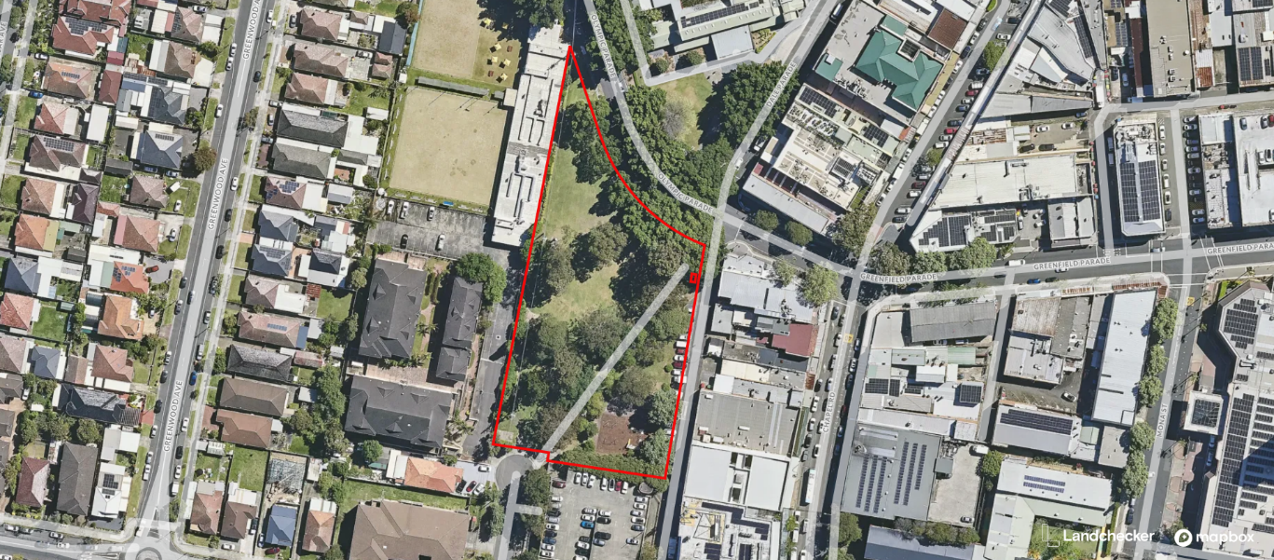
Figure 1: Aerial image of the site – Source: Landchecker

Existing improvements on the site include a children’s playground (future improved playground to provided elsewhere within the park) and land to the north which comprises general park area and a storage shed immediately adjacent to the multistorey public carpark.

Pursuant to clause 2.2 of Canterbury-Bankstown Local Environmental Plan 2023 (CBLEP) the site is zoned RE1 Public Recreation on the Land Zoning Map. Land to the north is zoned RE1, land to the west is zoned RE2 Private Recreation and R4 High Density. Land to the eats is zoned MU1 Mixed Use and SP2 Educational Establishment.

Community facilities are permissible with consent within the subject RE1 Public Recreation zone.

Council’s ‘Generic Plan of Management for Community Land and Crown Land for Community Land and Crown Land’ (PoM) identifies Griffith Park as comprising a mix of general community use and operational land. The site of the proposed works is wholly within the area designated for ‘general community use’.

  - The Locality

The subject site is bounded by Olympic Parade to the north, where the Bankstown Arts Centre is situated directly opposite, and the railway corridor lies further beyond. To the east, the park adjoins Dale Parade and a series of established commercial buildings that form part of the southern fringe of the Bankstown City Centre. Brandon Avenue and the Council-owned Brandon Avenue multi-storey carpark define the southern edge of the park, while to the west the site interfaces with existing 4-storey residential apartment buildings. Northam Avenue, located to the south-west, provides maintenance access into the park and serves surrounding residential properties, as well as the Bankstown Sports Bowls Club.

Within the south-eastern portion of Griffith Park, there is an existing children’s playground and open grassed park areas, as well as a small storage shed positioned adjacent to the multi-storey public carpark. The broader surrounds comprise a mix of civic, recreational, commercial and residential land uses that collectively contribute to the park’s role as a significant community open space within Bankstown.

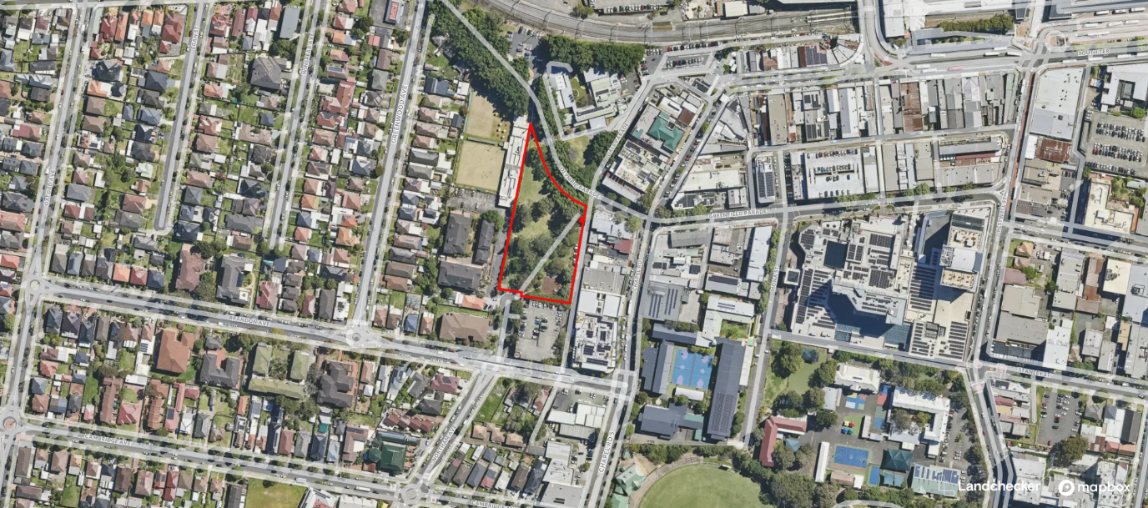
Figure 2: Locality map identifying the site – Source: Landchecker

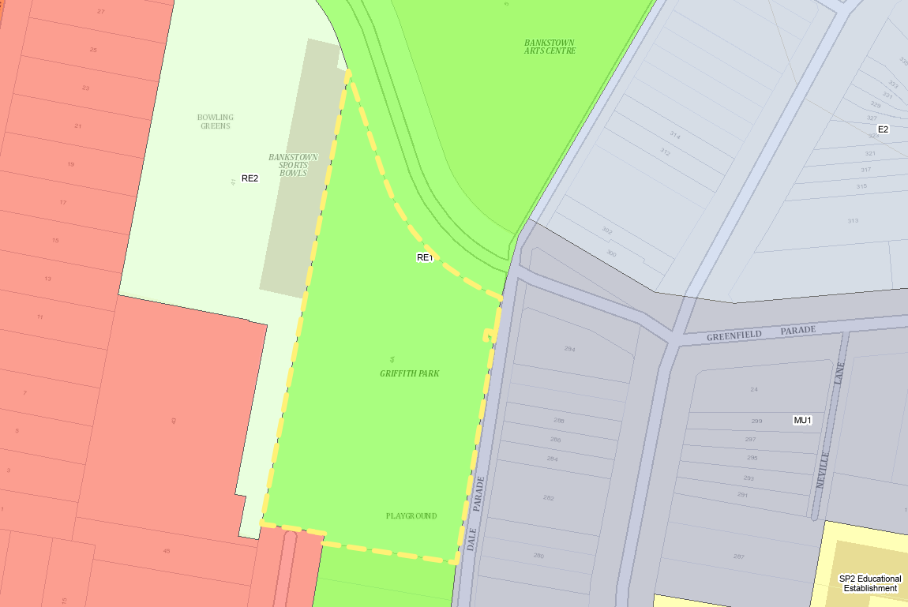
Figure 3: Land Zoning Map extract – Source: NSW Planning Portal Spatial Viewer

- THE PROPOSAL AND BACKGROUND

  - History

The site forms part of the wider Griffith Park which has historically been used for public recreation containing children’s play area and open park / recreation area with established vegetation.

A thorough search of Council’s records has been undertaken for past consents related to the site, however, the current structures on site predate Development Application records.

  - The Proposal

Overview

The development application seeks approval for demolition, tree removal and the construction of a new community centre and associated works at 4A Olympic Parade, Bankstown. Specifically, the development will comprise the following:

- Demolition of the existing playground in the south eastern corner of the park adjacent to Dale Parade;

- Removal of 18 trees;

- Construction of a new single storey community hub building (community facility) forming two pavilions set below a curved sloping roof form with intervening covered outdoor area providing for a range of flexible uses and spaces. The centre will have a total gross floor area of 570m² and contain the following:

- multipurpose hall
- multipurpose meeting room
- covered outdoor space
- foyer / lobby
- kitchen
- amenities and
- storerooms, waste room and plant areas

- Parking for 2 cars in the location of the existing shed to be demolished to the north of the existing Brandon Avenue car park;

- Reconfiguration and reduction in on street car parking on the western side of Dale Parade from ninety-degree parking comprising 19 spaces to 7 parallel spaces including one (1) accessible space; and

- Associated civil works and services including new electricity substation.

Operational Management

An Operational Plan of Management (PoM) has been prepared for the proposed Community Facility which outlines the proposed operation and management of the facility.

The facility will be a council managed facility for hire that benefits the local community. It will not be staffed and, it is anticipated that users will comprise:

- Cultural associations
- Hobby groups
- Seniors
- Community associations
- Community health and well-being services
- Youth groups
- Disability groups
- Children’s groups
- Theatre groups
- Government organisations
- Advocacy or political groups, and
- Other user groups.

The Centre is not a licensed premise or commercial/retail building. The facility will be open for public bookings and used within the following proposed hours of operation:

- Sunday to Thursday: 8am to 10pm, and

- Friday to Saturday: 8am to 12am.

The maximum capacity of the venue (in total) including hirer’s staff is 240 persons including hire of both the multi-purpose hall and the multi-purpose meeting room concurrently.

Use of the covered outdoor area will not be allowed after 6pm or before 7am to prevent noise impacts to neighbouring properties. Further doors and windows to internal areas will remain closed from 10pm to 7am.
Landscape Works

The proposed landscape works include the planting of trees, mass planted garden beds and rain gardens, pedestrian paths and ramps, retaining/ seating walls, timber seating deck.

Three new street trees are proposed in new garden beds on Dale Parade including Black She-Oak, Forest She-oak and/or Swamp She-oak with mass planting of the understorey below.

Traffic, access and parking

Two off-street car parking spaces are proposed as part of the proposed development to be located at ground level accessed off Northam Avenue to the north of the Brandon Avenue public car park. These spaces will be reserved for use by the hirers of the multi-purpose hall (1 space) and multi-purpose meeting room (1 space).

Vehicular access to the site is to be provided via the existing entry arrangements from Northam Avenue. Loading and servicing will also occur via the existing entry arrangements from Northam Avenue.

The proposed works also includes works within the Dale Parade roadway including reconfiguration and reduction in on-street car parking on the western side of Dale Parade from ninety-degree parking comprising 19 spaces to 7 parallel spaces including two (2) accessible spaces (a reduction of 12 spaces).

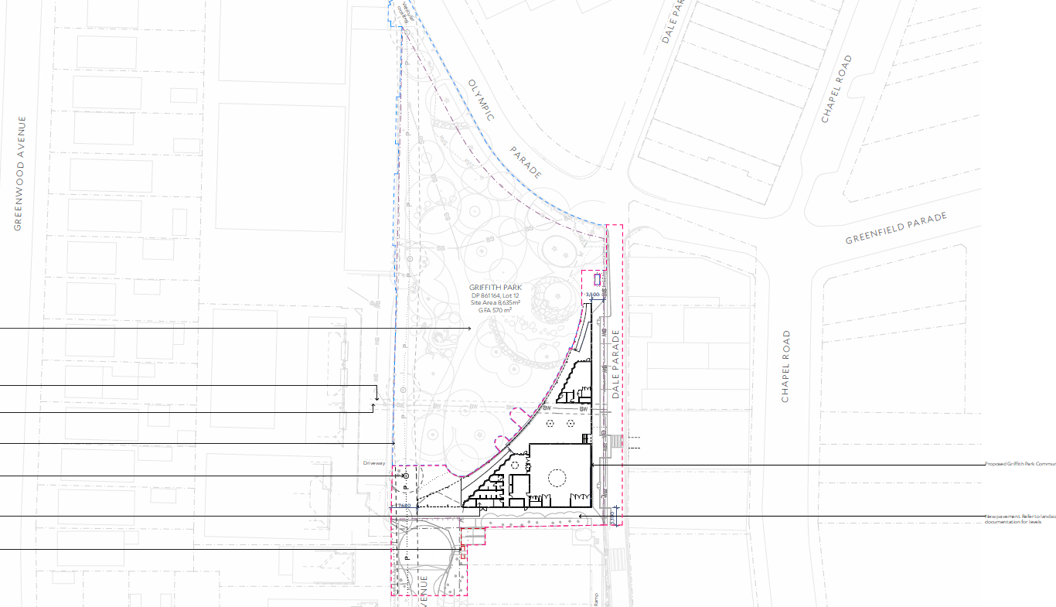
Figure 4: Proposed Site Plan – Source: Collins and Turner

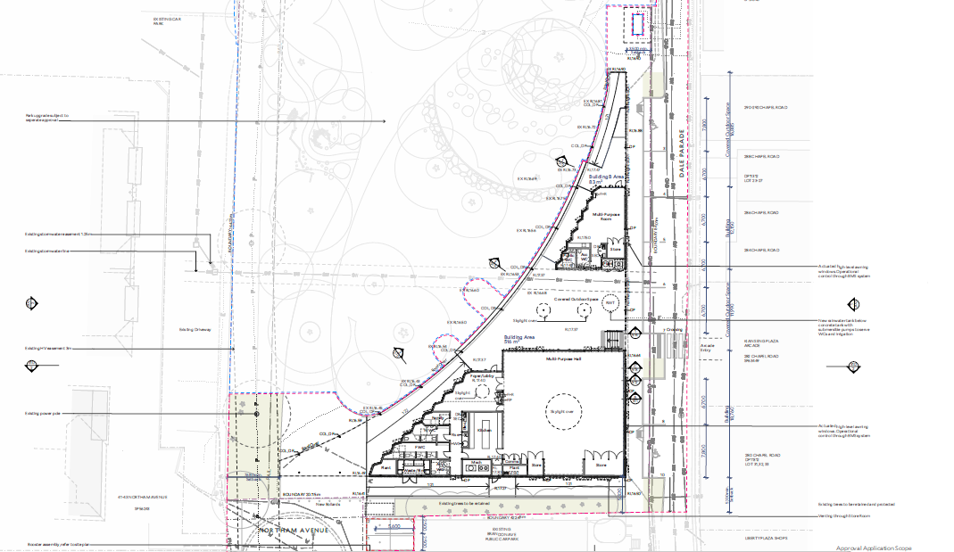
Figure 5: Proposed Ground Floor Plan – Source: Collins and Turner

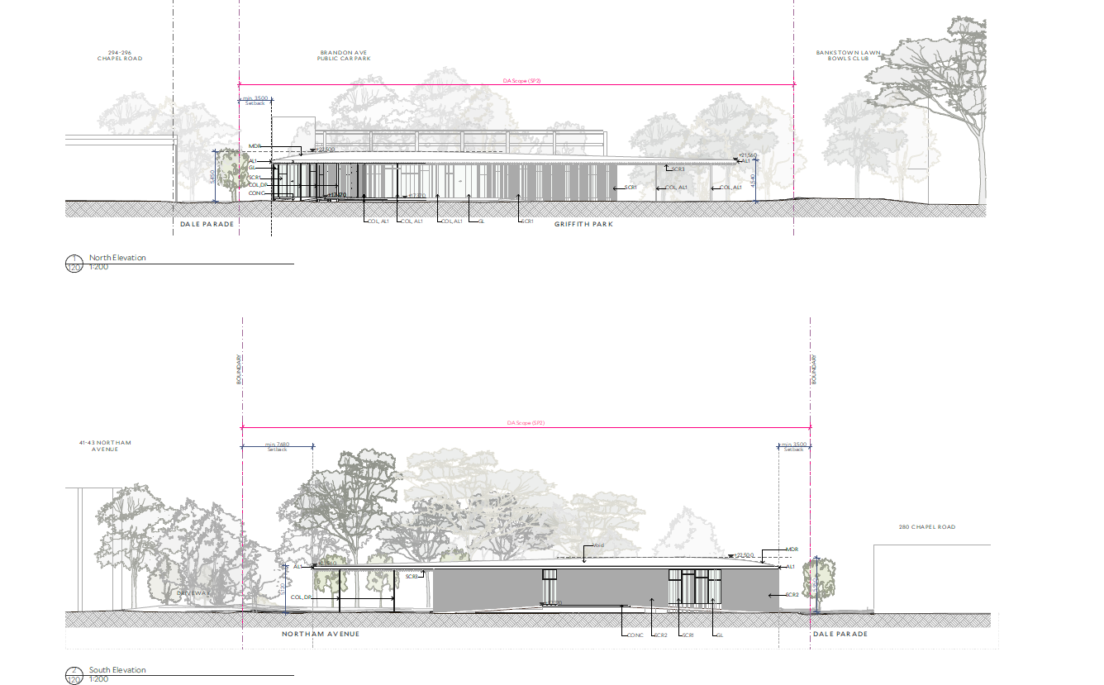
Figure 6: Proposed North and South Elevations – Source: Collins and Turner

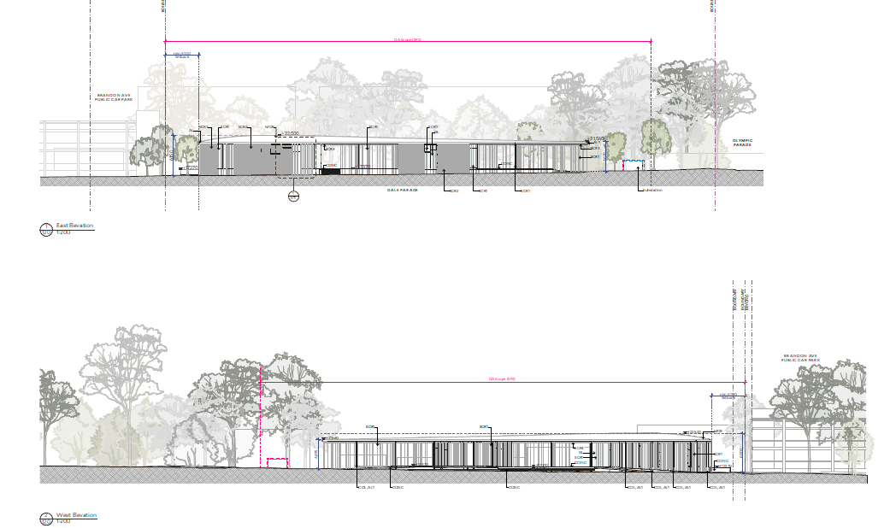
Figure 7: Proposed East and West Elevations – Source: Collins and Turner

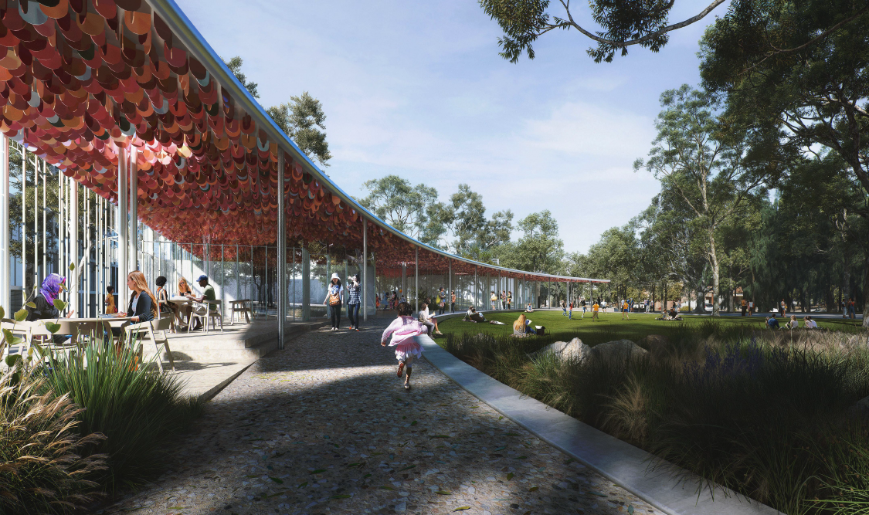
Figure 8: Montage view– Source: Collins and Turner
  - Background

The development application was lodged on 22 July 2025. A chronology of the development application since lodgement is outlined below including the Panel’s involvement (briefings, deferrals etc) with the application:

Table 1: Chronology of the DA
Date | Event
22 July 2025 | DA lodged
20 August 2025 | Exhibition of the application commenced
8 September 2025 | Sydney South Planning Panel attended site inspection
9 September 2025 | Exhibition of the application concluded
22 September 2025 | Request for Information issued to Applicant
16 October 2025 | Additional information provided by the Applicant
4 November 2025 | Second Request for Information issued to Applicant
14 November 2025 | Additional information provided by the Applicant

- STATUTORY CONSIDERATIONS

When determining a development application, the consent authority must take into consideration the matters outlined in Section 4.15(1) of the Environmental Planning and Assessment Act 1979 (‘EP&A Act’). These matters as are of relevance to the development application include the following:

- the provisions of any environmental planning instrument, proposed instrument, development control plan, planning agreement and the regulations
(i) any environmental planning instrument, and
(ii) any proposed instrument that is or has been the subject of public consultation under this Act and that has been notified to the consent authority (unless the Planning Secretary has notified the consent authority that the making of the proposed instrument has been deferred indefinitely or has not been approved), and
(iii) any development control plan, and
(iiia) any planning agreement that has been entered into under section 7.4, or any draft planning agreement that a developer has offered to enter into under section 7.4, and
(iv) the regulations (to the extent that they prescribe matters for the purposes of this paragraph),
that apply to the land to which the development application relates,
- the likely impacts of that development, including environmental impacts on both the natural and built environments, and social and economic impacts in the locality,
- the suitability of the site for the development,
- any submissions made in accordance with this Act or the regulations,
- the public interest.

In this regard, the following environmental planning instruments, development control plans, codes and policies are relevant and considered below:

- State Environmental Planning Policy (Biodiversity and Conservation) 2021
- State Environmental Planning Policy (Planning Systems) 2021
- State Environmental Planning Policy (Resilience and Hazards) 2021
- State Environmental Planning Policy (Transport and Infrastructure) 2021
- State Environmental Planning Policy (Sustainable Buildings) 2022
- Canterbury-Bankstown Local Environmental Plan 2023 (CBLEP 2023)
- Canterbury-Bankstown Development Control Plan 2023 (CBDCP 2023)
- Canterbury-Bankstown Local Infrastructure Contributions Plan 2022

These matters are further considered below.

It is noted that the proposal is not considered to be:

- Integrated Development (s4.46)
- Designated Development (s4.10)
- Crown DA (s4.33)

  - Environmental Planning Instruments, proposed instrument, development control plan, planning agreement and the regulations

The relevant environmental planning instruments, proposed instruments, development control plans, planning agreements and the matters for consideration under the Regulation are considered below.

- Section 4.15(1)(a)(i) - Provisions of Environmental Planning Instruments

The following Environmental Planning Instruments are relevant to this application.

- State Environmental Planning Policy (Biodiversity and Conservation) 2021
- State Environmental Planning Policy (Planning Systems) 2021
- State Environmental Planning Policy (Resilience and Hazards) 2021
- State Environmental Planning Policy (Transport and Infrastructure) 2021
- State Environmental Planning Policy (Sustainable Buildings) 2022
- Canterbury Bankstown Local Environmental Plan 2023

A summary of the key matters for consideration arising from these State Environmental Planning Policies are outlined in Table 2 and considered in more detail below.

Table 2: Summary of Applicable Environmental Planning Instruments
EPI | Matters for Consideration | Comply (Y/N)
State Environmental Planning Policy (Biodiversity & Conservation) 2021 | Chapter 2: Vegetation in non-rural areas  - Part 2.2 Clearing vegetation in non-rural areas: the development proposes the removal of vegetation on site, which is considered suitable based on existing vegetation and proposed landscaping.  Chapter 6: Water catchments  - Part 6.2 Development in regulated catchments: the application is accompanied by sufficient information to satisfy Council with regard to this development being in a regulated catchment. | Y
State Environmental Planning Policy (Planning Systems) 2021 | Chapter 2: State and Regional Development  - Part 2.4 Regionally significant development: in accordance with the criteria of Schedule 6, the development proposed is of regional significance, as the development exceeds an estimated development cost of $5 million and Council is the owner of the land on which the development is proposed. | Y
State Environmental Planning Policy (Resilience and Hazards) 2021 | Chapter 4: Remediation of Land  - Section 4.6 Contamination and remediation to be considered in determining development application:  A Contamination Assessment accompanies this application which concludes that, based on observations made during the field investigations and the sampling and analysis program conducted at the site, the site is suitable for the proposed land use and further assessment and/or remediation and validation is not considered to be warranted. | Y
State Environmental Planning Policy (Transport and Infrastructure) 2021 | Chapter 2: Infrastructure  Clause 2.48 - The application was referred to Transport for NSW (TfNSW) under Clause 2.48 of the SEPP. TfNSW raised no objection to the development subject to conditions. | Y
State Environmental Planning Policy (Sustainable Buildings) 2022 | Chapter 3: Standards for non-residential development  Section 3.2 – Development consent for non-residential development: the development is consistent with the requirements of this section through the management of waste, the inclusion of a solar panel array on the roof of the building, the use of low energy appliances and the use of rainwater and the installation of low water use fittings and fixtures.  The application is also accompanied by an Ecological Sustainable Development (ESD) Report and NABERS Embodies Emissions Materials Form which quantifies the embodied emissions attributable to the development. | Y
Proposed Instruments | There are no proposed instruments applicable to the subject site or the development typology. | N/A
CBLEP 2023 | - Clause 1.2 – Aims of plan: the development is consistent with the aims of the plan, regarding providing recreational and community service opportunities to meet the needs of residents and visitors to Canterbury-Bankstown while achieving good urban design in terms of site layouts, building from, streetscape and public and private safety and enhancing the social well-being and amenity of the community.  - Clause 2.7 - Demolition requires development consent – consent is sought for demolition under the application.  - Clause 4.3 – Height of buildings: no height of building restriction applies to the site.  - Clause 4.4 – Floor space ratio: no floor space ratio restriction applies to the site.  - Clause 5.10 – Heritage conservation: The site is not heritage listed and is not within a heritage conservation area. However, in proximity to the site is a heritage item known as ‘Olympic Parade and Dale Parade Fig Trees’ (item no. 247). Council’s Heritage Advisor has reviewed the proposal and advised that the proposal is supported from a heritage point of view.  - Clause 6.1 – Acid Sulfate Soils: The site is identified as comprising Class 5 acid sulfate soils. A geotechnical/acid sulfate soils investigation accompanies the application which clarifies that the site is not heavily impacted by acid sulfate soils and that the site is suitable for the proposed development. The investigations concludes that an acid sulfate soils management plan is not required for the development.  - Clause 6.2 – Earthworks: The development does not involve major earthworks. Conditions of consent have been imposed to manage cut and fill and ensure drainage patterns and soil stability are not adversely impacted.  - Clause 6.3 – Stormwater management and water sensitive urban design: Council’s Development Engineer has reviewed the submitted Stormwater Report and Plans and confirmed that, in principle, the proposed stormwater layout and configuration is satisfactory, subject to conditions.  - Clause 6.9 – Essential services: The site is readily serviced by reticulated water and sewer and electricity. Conditions of consent has been imposed to manage stormwater drainage, waste management and vehicular access. | Y
CBDCP 2023 | - Chapter 2.1 – Flood Risk Management: The development was referred to Council’s Development Engineers who raised no objection subject to conditions.  - Chapter 2.3 – Tree Management: The application proposes the removal of vegetation which is considered suitable subject to existing vegetation onsite and proposed landscaping.  - Chapter 3.1 – Development Engineering Standards: The application does not propose on-site stormwater detention and this is considered a suitable outcome in this instance owing to the information supplied in support of this application.  - Chapter 3.2 – Parking: The application proposes adequate parking and loading to service the development. The development was referred to Council’s Traffic Engineers who raised no objection subject to conditions.  - Chapter 3.3 – Waste Management: The development generally complies with requirements.  - Chapter 3.4 – Sustainable Development: The application generally complies with the requirements in relation to its effects to provide water conservation measures and efficient practices.  - Chapter 3.7 – Landscape: The application generally complies with requirements, subject to conditions.  - Chapter 4.4 – Development in the Vicinity of Places of Heritage Significance: The development is suitable for the site having regard to the site’s proximity to the locally listed heritage item (Olympic Parade and Dale Parade Fig Trees).  - Chapter 6.2 – Bankstown City Centre: The development aligns with the desired visions for the Bankstown City Centre. | Y

Consideration of the relevant SEPPs is outlined below:

State Environmental Planning Policy (Biodiversity and Conservation) 2021

Chapter 2 of SEPP (Biodiversity) aims to protect the biodiversity values of trees and other vegetation in non-rural areas of the State, and to preserve the amenity of non-rural areas of the State through the preservation of trees and other vegetation. Chapter 2 applies to the whole of Canterbury Bankstown Council, including the subject development site.

The accompanying Arboricultural Impact Assessment and Landscape Plans has identified the protection and retention of 50 trees and the removal of 18 trees. The Landscape Plan incorporates replacement tree planting to compensate for the proposed tree removal. The Arboricultural Impact Assessment has concluded that none of the trees proposed for removal are significant from a biodiversity perspective.

The Arboricultural Impact Assessment has been reviewed by Council’s Tree Management Officer who has concluded that removal of the vegetation is suitable for the site and consistent with the aims of SEPP (Biodiversity and Conservation) 2021 subject to replacement tree planting conditions which have been included within the accompanying conditions of consent.

Chapter 6 of SEPP (Biodiversity) applies to all development on land in a regulated catchment. Canterbury Bankstown Council includes land within the Georges River Catchment, in which the subject site falls. This chapter has no specific objectives but requires the consent authority to consider a number of matters which are addressed below:

Section 6.6 Water quality and quantity

- The application is accompanied with a Water Cycle Management report which indicates that the development will have no adverse impacts on the overall water quality and quantity.
- The application is accompanied by sufficient information in order to determine that the flow of water within the adjoining waterway will not be impacted, primarily as a result of potential excess stormwater run-off from this site.
- The application has supplied sufficient information to determine that the development will not provide for an increase in stormwater run-off compared to what exists on site today.
- The application is not expected to have any impact on the level or quality of the water table.
- The application is accompanied by sufficient information to determine the cumulative environmental impacts of the development on the catchment.
- The development would have a neutral impact on the quality and quantity of ground water.
- The development is expected to have a neutral impact on the quality of water entering the adjoining waterway.
- The application is accompanied by sufficient information to determine the impacts to the water flow within the adjoining waterway.

Section 6.7 Aquatic ecology

- The development is not expected to have an impact on aquatic ecology, noting that the development is not sited next-to or within close proximity to a waterway or riparian corridor.

Section 6.8 Flooding

- The site is known to be prone to flooding and this has been considered due to the fact that the site is within the Georges River catchment.
- A water cycle and flood management report accompanies the application which indicates that the development will not result in the release of pollutants that could potentially impact the water quality, nor would it have an adverse impact on the natural recession of floodwaters into wetlands or ecosystems.

Section 6.9 Recreation and public access

- The development will provide no impact on recreation or public access.

Section 6.10 Total catchment management

- Consultation with downstream councils has not been undertaken as it has not been demonstrated to what effect, if any, the development will have on the flow of water downstream to the subject site.

In light of the above comments, the development will not have any adverse impacts on the Georges River Catchment.

State Environmental Planning Policy (Planning Systems) 2021

Clause 2.19(1) of Part 2.4 of SEPP (Planning Systems) 2021 reads as follows;

Development specified in Schedule 6 is declared to be regionally significant development for the purposes of the Act.

Schedule 6 of SEPP (Planning Systems) 2021, in part, reads;

2 Council related development over $5 million

Development that has an estimated development cost of more than $5 million if –

- the Council is the owner of any land on which the development is to be carried out.

The EDC of the proposed development is proposed on Council owned land and exceeds $5 million. The development therefore qualifies as being a ‘regionally significant development’ and the Sydney South Planning Panel are the determining authority.

State Environmental Planning Policy (Resilience and Hazards) 2021

Chapter 4: Remediation of Land

The provisions of Chapter 4 of State Environmental Planning Policy (Resilience and Hazards) 2021 have been considered in the assessment of the development application. Section 4.6 of the SEPP requires consent authorities to consider whether the land is contaminated, and if the land is contaminated, it is satisfied that the land is suitable in its contaminated state (or will be suitable, after remediation) for the purpose for which the development is proposed to be carried out. In order to consider this, a Geotechnical, Contamination/Waste Classification and Acid Sulfate Soils Investigation has been prepared for the site and accompanies the application.

Having regard to the assessment set out above, the Panel can be satisfied that the development site is suitable for the proposed development, in accordance with clause 4.6(1) of SEPP (Resilience and Hazards) 2021.

State Environmental Planning Policy (Resilience and Hazards) 2021

Chapter 2: Infrastructure

Division 5 – Electricity transmission or distribution
Subdivision 2 Development likely to affect an electricity transmission or distribution network

Clause 2.48 of the SEPP applies to a development application for development comprising or involving any of the following—

- the penetration of ground within 2m of an underground electricity power line or an electricity distribution pole or within 10m of any part of an electricity tower,
- development carried out—
- within or immediately adjacent to an easement for electricity purposes (whether or not the electricity infrastructure exists), or
- immediately adjacent to an electricity substation, or
- within 5m of an exposed overhead electricity power line,

- installation of a swimming pool any part of which is—
- within 30m of a structure supporting an overhead electricity transmission line, measured horizontally from the top of the pool to the bottom of the structure at ground level, or
- within 5m of an overhead electricity power line, measured vertically upwards from the top of the pool,

- development involving or requiring the placement of power lines underground, unless an agreement with respect to the placement underground of power lines is in force between the electricity supply authority and the council for the land concerned.

The application was referred to TfNSW who was delegated to act as the electricity supply authority and to process the review for this Development Application that is in proximity to electricity infrastructure. TfNSW raised no objection to the development subject to conditions that have been included in the recommended conditions of consent.

Canterbury Bankstown Local Environmental Plan 2023
The relevant local environmental plan applying to the site is the Canterbury Bankstown Local Environmental Plan 2023 (‘the LEP’).

Aims

The aims of the LEP include:

- to protect and promote the use and development of land for arts and cultural activity, including music and other performance arts,
- to manage growth in a way that contributes to the sustainability of Canterbury-Bankstown,
- to protect landforms and enhance vegetation, especially foreshores and bushland, in a way that maintains the biodiversity values and landscape amenity of Canterbury-Bankstown,
- to provide a range of recreational and community service opportunities and open spaces to meet the needs of residents of and visitors to Canterbury-Bankstown,
- to achieve good urban design in terms of site layouts, building form, streetscape, architectural roof features and public and private safety,
- to consider the cumulative impact of development on the health of the natural environment and waterways and on the capacity of infrastructure and the road network,
- to support healthy living and enhance the quality of life and the social well-being and amenity of the community,
- to ensure development is accompanied by appropriate infrastructure,
- to promote ecologically sustainable development.

The proposal is consistent with the aims of the LEP as it will deliver a revitalised, well designed community centre to meet the social needs of residents of and visitors to Canterbury Bankstown.

Zoning and Permissibility

The site is zoned RE1 Public Recreation pursuant to clause 2.2 of the LEP.

A community facility is a permissible form of development within the zone.

According to the definitions in Clause 4 (contained in the Dictionary), the proposal satisfies the definition of community facility which is a permissible use with consent in the Land Use Table in Clause 2.3.

The zone objectives include the following (pursuant to the Land Use Table in Clause 2.3):

- To enable land to be used for public open space or recreational purposes.
- To provide a range of recreational settings and activities and compatible land uses.
- To protect and enhance the natural environment for recreational purposes.
- To promote a high standard of urban design and local amenity.

The proposal is considered to be consistent with these objectives through the provision of a community facility to meet the needs of the community within the established Griffith Park precinct. The design of the development promotes a high standard or urban design and local amenity.

General Controls and Development Standards

The LEP also contains controls relating to development standards, miscellaneous provisions and local provisions. The controls relevant to the proposal are considered in Table 3 below.

Table 3: Consideration of the LEP Controls
Control | Requirement | Proposal | Comply
Cl. 5.10  Heritage conservation | Assesses the extent to which the carrying out of the proposed development would affect the heritage significance of the heritage item or heritage conservation area concerned. | The site is not heritage listed and is not within a heritage conservation area. There is a heritage listed item in proximity to the site which is known as Olympic Parade and Dale Parade Fig Trees. Council’s Heritage Advisor has reviewed the proposal and advised that the proposal is supported from a heritage point of view. | Y
Cl 6.1  Acid Sulfate Soils | Under the provision development consent is required where works are within 500m of adjacent Class 1, 2, 3 or 4 land that is below 5m Australian Height Datum and by which the water table is likely to be lowered below 1m Australian Height Datum on adjacent Class 1, 2, 3 or 4 land. Where the above applies an acid sulfate soils management plan is required | The Acid Sulfate Soils investigation that accompanies this application indicates that the site is not heavily impacted for acid sulfate soils. The investigations concludes that an acid sulfate soils management plan is not required for the development. | Y
Cl. 6.2  Earthworks | Ensure that earthworks will not have a detrimental impact on environmental functions and processes, neighbouring uses. | The application proposes minor earthworks to accommodate the development. Conditions of consent have been imposed to manage cut and fill and ensure drainage patterns and soil stability are not adversely impacted. | Y
Cl. 6.3 Stormwater management and water sensitive urban design | Avoid or minimise the adverse impacts of urban stormwater on land to which this clause applies and on adjoining properties, native bushland, waterways and ground water systems. | Council’s Development Engineer has reviewed the submitted Stormwater Report and Plans and confirmed that, in principle, the proposed stormwater layout and configuration is satisfactory, subject to conditions. | Y
Cl. 6.9 – Essential services | Services that are essential for the development are to be available or that adequate arrangements have been made to make them available when required. | The site is readily serviced by reticulated water and sewer and electricity. Conditions of consent has been imposed to manage stormwater drainage, waste management and vehicular access. | Y

The proposal is considered to be generally consistent with the LEP.

- Section 4.15 (1)(a)(ii) - Provisions of any Proposed Instruments

There are no applicable proposed instruments.

- Section 4.15(1)(a)(iii) - Provisions of any Development Control Plan

The following Development Control Plan is relevant to this application:

- Canterbury Bankstown Development Control Plan 2023 (‘the DCP’)

Table 4: Consideration of the DCP Controls
Control | Requirement | Proposal | Comply
Chapter 2.1  Site Analysis | Requires site analysis plan for specified forms of development – community centres not included. | A Site Analysis has been provided and is deemed sufficient. | Y
Chapter 2.2  Flood Risk Management  3.1 | The proposed development should not result in any significant increase in risk to human life, or in a significant increase in economic or social costs as a result of flooding. | The development does not look to increase risk to human life or the like. | Y
Chapter 2.2  Flood Risk Management  3.2 | The proposal should only be permitted where effective warning time and reliable access is available to an area free of risk from flooding, consistent with any relevant flood plan or flood evacuation strategy. | The site maintains reliable access in the case of a flood event. | Y
Chapter 2.2  Flood Risk Management  3.3 | Development should not significantly increase the potential for damage or risk other properties either individually or in combination with the cumulative impact of development that is likely to occur in the same floodplain. | The development will not significantly increase the potential for damage or risk in any way. | Y
Chapter 2.2  Flood Risk Management  3.7 | Development should not result in significant impacts upon the amenity of an area by way of unacceptable overshadowing of adjoining properties, privacy impacts (e.g. by unsympathetic house-raising) or by being incompatible with the streetscape or character of the locality. | The development does not result in any adverse impacts on the existing amenity of the area. | Y
Chapter 2.3  Tree Management  2.10  Approval granted by Council | A permit granted by Council or development consent may be subject to the requirement to plant suitable replacement trees on the site, offset tree planting, or any other conditions deemed suitable by Council. The replacement planting is to be completed within 28 days of the tree removal works, or as otherwise specified by Council. | The accompanying Arboricultural Impact Assessment and Landscape Plans has identified the protection and retention of 50 trees and the removal of 18 trees onsite. The Landscape Plan incorporates replacement tree planting to compensate for the proposed tree removal. The development is supported by Council’s Tree Management Officer, subject to conditions, which have been incorporated into the consent. | Y
Chapter 3.1 – Development Engineering Services
Section 2 – Civil Engineering Requirements
2.4  Sight distance requirements | Adequate sight distance must be provided for vehicles exiting driveways. Clear sight lines are to be provided at the street boundary to ensure adequate visibility between vehicles on the driveway and pedestrians on the footway and vehicles on the roadway. Refer to the Australian Standard AS 2890.1 for minimum sight distance requirements. | Council’s Traffic Engineering Officer reviewed the proposal and raises no issue with sight distances. | Y
Section 3 – Stormwater Drainage Systems
3.2  Disposal of Stormwater runoff | Site stormwater drainage systems should be designed to flow under gravity, and be connected to Council's stormwater drainage system at the nearest suitable location or CDL benefiting the site. Site drainage design should follow the natural fall of the catchment to a pipeline connection point that has been designed for the runoff. | The application is accompanied by Stormwater Plans and a Stormwater & flood management report. Council is satisfied that the proposed stormwater and civil arrangement is appropriate. | Y
3.4  Roof Gutter Design | Roof, eave and/or box gutters and downpipes must be sized using the formulas and tables provided in accordance with the Australian Standard AS/NZS 3500 and Table 4b. In the case of OSD design, where overflow of the roof system cannot be directed to the OSD system, the roof stormwater drainage system must be designed for the 100-year ARI storm. | Councils’ development engineers have reviewed the proposed stormwater arrangement and raised no concerns subject to conditions of consent. | Y
Section 4 – On-Site Detention System
4.2  Multi-Dwelling and non residential development | Multi-dwelling development and non-residential development will require OSD regardless of the impervious area before and after the development, and regardless of whether the site falls toward or to the street. | Council is satisfied that the development does not require an OSD due to the site being flood liable. Councils engineering team raised no issues regarding this. | Y
Chapter 3.2 – Parking
Section 2 – Off-Street Parking Rates
2.1  Off–street parking rates | Where a development is not included (community facilities) in the Off-Street Parking Schedule a parking study must be submitted for Council's consideration. A qualified traffic consultant must prepare the parking study. | Two (2) parking spaces are provided as part of the development. These are said to be utilised by the hirers of the venue.  Parking for visitors will rely on the existing car parking facilities, active transport and public transport. A Traffic Impact Assessment accompanies the application, and Councils Traffic team raised no concerns. | Y
Section 3 – Design and Layout
3.1  Parking Location | Development must not locate entries to car parking or delivery areas:  (a) close to intersections and signalised junctions;  (b) on crests or curves;  (c) where adequate sight distance is not available;  (d) opposite parking entries of other buildings that generate a large amount of traffic (unless separated by a raised median island);  (e where right turning traffic entering may obstruct through traffic;  (f) where vehicles entering might interfere with operations of bus stops, taxi ranks, loading zones or pedestrian crossings; or  (g) where there are obstructions which may prevent drivers from having a clear view of pedestrians and vehicles. | The proposed parking arrangement is considered appropriate. | Y
3.9  Access driveway width and design | The appropriate driveway width is dependent on the type of parking facility, whether entry and exit points are combined or separate, the frontage road type and the number of parking spaces served by the access facility. | Vehicular access is proposed via Northam Avenue. An existing vehicular crossover exists here. | Y
3.43  At-grade parking | Avoid car parking areas and access driveways characterised by large expanse of bare concrete. | The two (2) new car parking spaces do not create an adverse visual impact. Sufficient landscaping is also proposed to detract from all proposed concreting and hardstand areas. | Y
3.45  At-grade parking | Use perforated paving materials (for example, paving units with wide bands of gravel aggregates) that allow infiltration of stormwater. | The stormwater report and plans demonstrate that the proposed stormwater layout and configuration is satisfactory. | Y
3.46  At-grade parking | Trees are to be planted at the ratio of one tree per five car park places allocated. Species are to be selected for their ability to thrive where compaction and deoxygenation are characteristic of the soils. | Not Applicable. The development proposes two (2) parking spaces. Sufficient landscaping and canopy exists on site. | Y
3.4 Sustainable Development
Section 2 – Water Conservation
2.3 | Requirement W1: Use of water efficient fixtures 2.3 The following requirement is mandatory and must be incorporated into the building design: All taps, showerheads, toilet suites (cisterns, urinals) used in the development must be rated to at least 4 stars under the National Water Efficient Labelling and Standards (WELS) Scheme (refer below). National water conservation rating and labelling scheme The Water Efficient Labelling and Standards (WELS) Scheme is administered by the NSW and Australian Government and is designed to make more efficient use of Australia’s potable water supply. The following star ratings are required for compliance with this DCP: (a) shower heads 3 stars – 8 litres or less per minute; (b) (c) basins taps 6 stars – 4.5 litres or less per minute; toilet cisterns 4 stars – 4 litres or less per flush. | The provided ESD report prepared by Steensen Varming demonstrates that the proposed development will align with this requirement. | Y
Section 3 – Energy Minimisation
3.2 | Requirement E1: Energy efficient building design 3.2 The design and orientation of buildings must maximise solar access and natural lighting by:  Orientating the building so that its longest side is on the east west axis (where possible).  Maximising the number of windows on the northern face of the building and minimising glazed areas on the eastern and western walls of the building (i.e. providing for most of the glazed areas on the northern face of the building). | The development has an energy efficient building design wit no adverse energy-related impacts. An ESD report has also been provided to support the development. | Y
3.3 | Development must incorporate a hot water heating system that is energy rated to at least 4 stars. The preferred system is either a gas boosted solar system, or a 5 star gas system, with appropriate insulation to the tank and pipes | An ESD report has been provided demonstrating that the proposed hot water system will have an energy rating of at least 4 stars. | Y
Chapter 3.7 Landscape
Section 2 – Landscape Design
2.1  Existing Vegetation and Natural Features | New landscaping is to complement the existing street landscaping and improve the quality of the streetscape. | The landscape design for the development will increase activation, foster a diverse outdoor learning environment, provide comfort and shade, increase biodiversity and playfully manage water in the landscape. The landscape design also plays an important role in stitching the site together, connecting the western park frontage through to the early learning centre. | Y
2.3  Design and Location of landscape | The landscape design is to contribute to and take advantage of the site characteristics. | The proposed landscaping is considered sufficient and will contribute to the sites characteristics. | Y
2.6  Trees | Development must consider the retention of existing trees, including street trees, in the building design. | Where possible, existing trees have been incorporated into the proposed landscape design. Replacement planting has been proposed to compensate for those trees that are unable to be retained. | Y
2.7  Trees | Development must plant at least one canopy tree for every 12m of front and rear boundary width | The site is already heavily vegetated and 50 trees are to be retained. | N/ Variation Supported
3.1  Biodiversity | Development must retain, protect and enhance indigenous/native vegetation and natural site features and incorporate it into the landscape design. | Sufficient native and indigenous landscaping has been provided | Y.
Chapter 4.4 – Development in the Vicinity of places of Heritage Significance
Chapter 4.4  1.1  Development in the vicinity of places of heritage significance | The design of development must:  (a) respond to the setting, setbacks, form, scale and style of nearby places of heritage significance;  (b) maintain significant views to and from the place of heritage significance;  (c) ensure adequate setbacks from the site of the place of heritage significance to retain its visual setting;  (d) retain original or significant landscape features that are associated with the place of heritage significance or that contribute to its setting;  (e) use materials, finishes and colours selected to avoid strong contrast with the place of heritage significance in order to retain its visual importance or significance. | The site is not heritage listed and is not within a heritage conservation area. However in proximity to the site is a heritage item known as ‘Olympic Parade and Dale Parade Fig Trees’ (item no. 247).Council’s Heritage Advisor has reviewed the proposal and advised that the proposal is supported from a heritage point of view | Y
Chapter 6.2 Bankstown City Centre
Section 3  3.1 Streets | Street Hierarchy  C1. Applicants must give regard to the street typologies included in the map in Figure 12, typical sections in Figure 13-19, and Bankstown Complete Streets as a key part of their site and context analysis submitted with the Development Application. Refer to Bankstown Complete Streets CBD Place and Movement Plan for more information.  Pedestrian and Cycle Connections and through site-links  C1. Provide new pedestrian and cycling through site links in accordance with Figure 20. | The proposed development does not have an adverse impact on the envisaged public domain.  The development does not hinder the ability for the future addition of a site link through Griffith Park. | Y
3.2 Tree Canopy and Green Cover | C14. Architectural and Landscape plans and sections submitted with a Development Application are to be coordinated and provide sufficient information for Council to assess the growing conditions of trees, | Sufficient information has been provided in both the Architectural and Landscape plans. | Y
4.1 Minimum Lot Sizes, frontages and Isolated Sites | C1. Development must not result in the creation of an isolated site that could not be reasonably developed in compliance with the relevant planning controls, including the CBLEP2023 and this DCP. | The development does not result in the creation of an isolated site. | Y
4.4 Building Interface with open space | C1. Where buildings address public open space, the design is to maximise direct access for all occupants from the ground floor.  C4. Where a building has a direct frontage to public open space, the design of the building is to minimise visual impact on the open space and provide a positive contribution. | The proposed buildings have direct access to the open space within Griffith Park.  The design of the community centre has no adverse impact on the open space areas. | Y
4.7 Materials and finishes | C1. Buildings must include durable single material finishes such as masonry and/or off form concrete. Painted cement render or similar painted finishes and Aluminium Composite Panel Cladding (e.g. Alucobond) must not be used within the podium levels of buildings and must not comprise more than 25% of each facade above podium level. | All building materials are deemed to be suitable and durable for the proposed development. | Y
5.2.1 Parking | C4. All car parking within the Bankstown City Centre must be provided in accordance with the rates as specified in Figure 58. If a land use is not included in Figure 58 the car parking rates in Section 2 Chapter 3.2 of the CB DCP 2023 will apply. | Parking rates are not specified as a land use in Figure 58. Parking has been assessed above in Section 2. | Y
5.9 Design for flood affected properties | C1. Development Applications for new development located on land identified in Figure 56 must provide a Flood Impact and Risk Assessment (FIRA) prepared in accordance with the Flood Risk Management Manual including Flood Impact and Risk Assessment Flood Risk Management Guideline LU01 published on 30 June 2023 that demonstrates how the occupants of the development once constructed will be able safely to ‘shelter in place’ for the duration of a Probable Maximum Flood (PMF) event. | The site is not identified within Figure 56 as a Flood Affected Property. | Y

Development Contributions

The development is not subject to a development contribution under the Canterbury Bankstown Local Infrastructure Contributions Plan 2022.

- Section 4.15(1)(a)(iiia) – Planning agreements under Section 7.4 of the EP&A Act

There have been no planning agreements entered into and there are no draft planning agreements being proposed for the site.

- Section 4.15(1)(a)(iv) - Provisions of Regulations

The proposal is consistent with the relevant provisions of the Regulations.

  - Section 4.15(1)(b) - Likely Impacts of Development

The likely impacts of that development, including environmental impacts on both the natural and built environments, and social and economic impacts in the locality must be considered. In this regard, potential impacts related to the proposal have been considered in response to SEPPs, LEP and DCP controls outlined above and the Key Issues section below.

- Context and setting – The proposal is considered to be consistent with the context of the site, acknowledging that the proposed Community Centre will be located at the existing Griffith Park. The proposed development is also considered appropriate in terms of bulk and scale and its relationship with adjoining and surrounding development.

- Access and traffic – The proposed development has been assessed by Council’s Traffic Engineer who has confirmed that the development suitable for the locality and that it would not bring about adverse impacts on traffic in the area, subject to conditions of consent.

- Utilities – The site and existing community centre is readily serviced by reticulated water and sewer and electricity. The resultant development would not generate any adverse impacts on the utility infrastructure within the area.

- Contamination – The development has been reviewed by Council’s Environmental Health Officer, the land is suitable for the proposed development subject to conditions of consent.

- Natural hazards – the application is satisfactory in terms of information to allow the consent authority to determine that the development would not provide for unacceptable levels of hazards to both personal safety and life as well as economic impacts.

- Economic impact – the proposal would provide for an increase in economic activity by delivering an upgraded, modern, well-designed community facility with good access to public transport for the benefit of the local community.

- Site design and internal design – the proposal is appropriately sited and designed on the site.

Accordingly, it is considered that the proposal will not result in any significant adverse impacts in the locality as outlined above.

  - Section 4.15(1)(c) - Suitability of the site

The proposal is suitable for the site. The proposed Community Centre will further enhance the existing use and operation of Griffith Park. The proposed community centre is located within Griffith Park, which is identified in Council’s ‘Generic Plan of Management for Community Land and Crown Land for Community Land and Crown Land’ as comprising general community use.

The site of the proposed works is within the area designated for ‘general community use.’ The site is considered suitable for the proposed development, which will deliver an enhanced community facility for the benefit of the local community.

  - Section 4.15(1)(d) - Public Submissions

The proposal was notified in accordance with the Council’s Community Participation Plan from 20 August 2025 to 9 September 2025. Zero submissions were received during the notification period.

  - Section 4.15(1)(e) - Public interest

Approval of the development will be within the public interest as demonstrated within this report.

- REFERRALS AND SUBMISSIONS

  - Agency Referrals and Concurrence

The development application has been referred to various agencies for comment as required by the EP&A Act and outlined below in Table 5.

There are no outstanding issues arising from these concurrence and referral requirements.

Table 5: Concurrence and Referrals to agencies
Agency | Concurrence/  referral trigger | Comments  (Issue, resolution, conditions) | Resolved
Concurrence Requirements (s4.13 of EP&A Act)
N/A | None | None | N/A
Referral/Consultation Agencies
TfNSW | There is an existing 6.1m easement for railway purposes through the western boundary of the site. Electrical Easement | Subject to Conditions | Y
Integrated Development (S 4.46 of the EP&A Act)
N/A | None | None | N/A

  - Council Officer Referrals

The development application has been referred to various Council officers for technical review as outlined Table 6.

Table 6: Consideration of Council Referrals
Officer | Comments | Resolved
Asset Systems Planning | Council’s Asset Planning team reviewed the proposal and concluded that the amended documentation was acceptable subject to conditions | Y
Building Surveyor | Council’s Building Surveyor reviewed the proposal and provided conditions of consent. | Y
Community Safety | Council’s Community Safety Officer reviewed the proposal and provided conditions of consent. | Y
Engineer | Council’s Development Engineer reviewed the proposal and concluded that the amended documentation was acceptable subject to conditions. | Y
Environmental Health | Council’s Environmental Health Officer reviewed the proposal and provided conditions of consent. | Y
Heritage Advisor | Council’s Heritage Advisor reviewed the proposal and provided conditions of consent. | Y
Landscape Architect | Council’s Landscape reviewed the proposal and provided conditions of consent. | Y
Traffic Engineer | Council’s Traffic Engineer reviewed the proposal and concluded that the amended documentation was acceptable subject to conditions. | Y
Tree Management Officer | Council’s Tree Management Officer reviewed the proposal and concluded that the amended documentation was acceptable subject to conditions . | Y
Waste Resource Recovery | Council’s Waste Resource Recovery Officer reviewed the proposal and provided conditions of consent. | Y

The outstanding issues raised by Council officers are considered in the Key Issues section of this report.

  - Community Consultation

The proposal was notified in accordance with the Council’s Community Participation Plan from 20 August 2025 to 9 September 2025. The notification included the following:

- A sign placed on the site;
- Notification on a website;
- Notification letters sent to adjoining and adjacent properties;
- Notification on the Council’s website.

The Council received no submissions.

  - Panel Briefing

A site inspection was undertaken by the Panel on 8 September 2025 where the proposed development and key issues were discussed. The Panel noted the following:

Tree ID 35 (the Angophora costata) was identified on-site as being healthy specimen. As such they’ve requested the applicant explore opportunities for its retention.
Response
Detailed consideration has been given to the potential to retain Tree 35 by the applicant however they have advised it is not possible given its location immediately adjacent to the community centre building footprint.
The design of the centre provides a wide through site link between the new community centre and the existing car park providing good sight lines, retention of existing plantings and ensuring consistency with CPTED principles. The loss of the tree in this circumstance is unavoidable and justifiable. The proposed design and public amenity benefits delivered by the proposed community centre and the extensive number of other mature trees to be retained within the wider park site provide justification for the proposed removal in this instance.

An explanation / clarification as to why the number of spaces that exist along Dale Parade are proposed to be reduced.
Response
The reduction of parking spaces along Dale Parade results from the reconfiguration from angled to parallel parking supports broader public domain works associated with the community centre, including wider pedestrian paths, improved landscaping, and enhanced visibility near the crossing. The reconfiguration and reduction in spaces is in alignment with the Complete Streets principles aiming to improve safety, streetscape quality, and community
amenity.

To understand existing kerbside use the applicant’s Traffic Consultant undertook an on-site observation survey between 7:00 am and 8:00 am on 9 October 2025, focusing on the Dale Parade frontage.

This period was selected based on industry experience as the typical peak hour for loading and servicing activity prior to nearby shops and businesses opening for morning trade. Both parking and loading activity were observed during this period, confirming that approximately three to four spaces are regularly used for loading and unloading rather than long-stay parking.
Based on the survey and location of the spaces the reduction in parking is not considered to result in adverse impacts on the locality and will still allow for sufficient short term parking arrangements.

The application and additional clarification from the applicant were referred to Council’s Traffic Engineer who raised no objection subject to conditions.

- CONCLUSION

This development application has been considered in accordance with the requirements of the Environmental Planning & Assessment Act 1979 and the Regulations as outlined in this report. Following a thorough assessment of the relevant planning controls and the key issues identified in this report, it is considered that the application is worthy of support.

The application proposes an acceptable built form outcome and land use and is generally consistent with what is expected to be provided within an RE1 Public Recreation zone.

Based on the assessment contained within this report, it is recommended that the application be approved subject to recommended conditions of consent.

- RECOMMENDATION

That Development Application No. DA-811/2025 be APPROVED pursuant to Section 4.16(1)(a) of the Environmental Planning and Assessment Act 1979 subject to the draft conditions of consent attached to this report at Attachment A.

The following attachments are provided;

- Attachment A: Draft Conditions of Consent.
- Attachment B: Architectural Plans
- Attachment C: Landscape Plans
- Attachment D: Civil Engineering Plans
- Attachment E: Traffic Impact Assessment
- Attachment F – Operational Plan of Management

